**ТЕМАТИЧЕСКИЙ ПЛАН ЛЕКЦИЙ**

**Discipline Radiology**

**Direction of training 31.05.01 General Medicine**

**Term - 6**

**Course – 3**

|  |  |  |  |
| --- | --- | --- | --- |
| **Дата** | **Тема лекции** | | **Кол-во часов** |
|  | Radiological examination of diseases of the urinary system | | 2 |
|  | Radiological examination of diseases and injuries of the musculoskeletal system | | 2 |
|  | Modern methods of diagnosing breast diseases | | 2 |
|  | | **Итого** | **6** |

Rewieved at the meeting of the Department of Radiology,

Radiation Therapy and Oncology

Protocol #

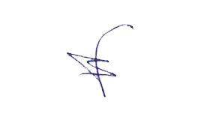

Head of the Department of Radiology,

Radiation Therapy and Oncology M.Yu. Valkov

Рассмотрено на заседании кафедры лучевой диагностики,

лучевой терапии и онкологии

Протокол №

Заведующий кафедрой лучевой диагностики,

лучевой терапии и онкологии М.Ю. Вальков